 |  | Consumer Research Expert
ConsumerInsight Report
(2020 Travel Report)
Company | ConsumerInsight |  | E-mail | kwonyg@consumerinsight.kr
Inquiry | Kwon, Younggyo / Director |  | Phone number | 02) 6004-7622
Issued | December 1st, 2020 (Tuesday) |  | Pages | 3 pages in total

Yanolja dominating for four years in a row, Naver racing up alone
ConsumerInsight, online travel product platform usage survey
- Online travel product platform usage decreased for the first time due to COVID 19
- Domestic brands stand strong - the market reshaping itself with foreign brands getting weaker
- Yanolja, ranked 1st for consecutive four years...
Naver rose to 2nd place, threatening Yeogiatae(Goodchoice)
- A huge opportunity for local platforms if the global market opens again

The number of consumers using online travel product platforms declined for the first time. This is because the travel industry shrank due to COVID 19. As overseas travel was virtually blocked, domestic travel platforms such as Yanolja, Yeogiatae(Goodchoice), and Naver Airline/Hotel enjoyed positive reflections, while overseas brands struggled. Yanolja ranked first in the consumer experience rate for four consecutive years, and Naver, which has grown rapidly, is poised to overtake the second place. Due to the influence of COVID 19, the online travel product platform market is undergoing significant changes.
ConsumerInsight, a travel research specialist, abridged the results of its annual ‘travel product satisfaction study’ on consumers’ use of specialized travel product booking web/app (platforms). The study asked 13,036 people if they had used major brands such as online travel agencies (OTA), accommodation apps in the past one year (from September 2019 to August 2020). In the survey, some 23 brands were asked, including GogoSing, Naver Airline/Hotel, Daily Hotel, My Real Trip, Booking.com, Skyscanner, Agoda, Yanolja, Airbnb, Yeogiatae(Goodchoice), Waug, Expedia, Kayak, Kyte, KK-Day, Klook, Trivago, Triple, Trip.com, Hostelworld, Hotels.com, Hotelscombined (in Korean Alphabetical order) [Figure1].

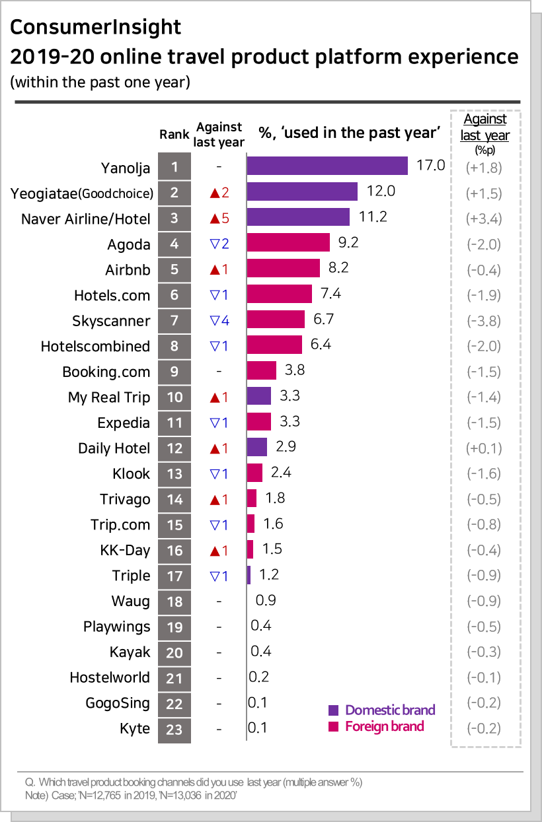
[Figure1] 2019-20 online travel product platform experience (within the past one year)

■ Domestic platforms occupying all 1st, 2nd and 3rd places
Yanolja ranked first for four consecutive years as a online travel product platform that consumers have used within the past year. The brand is doing well with the experience rate of 17.0%, 1.8% point up from last year. Yeogiatae (Goodchoice), the second place, increased by 1.5%p to 12.0%, stepping up two places from the previous year. Naver Airline/Hotel jumped to 3rd place at 11.2%, an increase of 3.4%p from the previous year, and followed Yeogiatae (Goodchoice), the 2nd place, closing in the gap with brand. Other than these big 3 brands, My Real Trip and Daily Hotel ranked 10th and 12th, respectively, forming the mid-tier group, but declined or stagnated, compared to the previous year, moving away from the leader group [Figure2].
What stood out the most of the survey was the good advancement of Naver Airline/Hotel. With its powerful accessibility, search function, and content of the portal, Naver is chasing Yanolja and Yeogiatae(Goodchoice) closely. There is a 5.8%p gap with Yanolja, but considering its 3.4%p increase this year, Naver is likely to hit the leader soon.

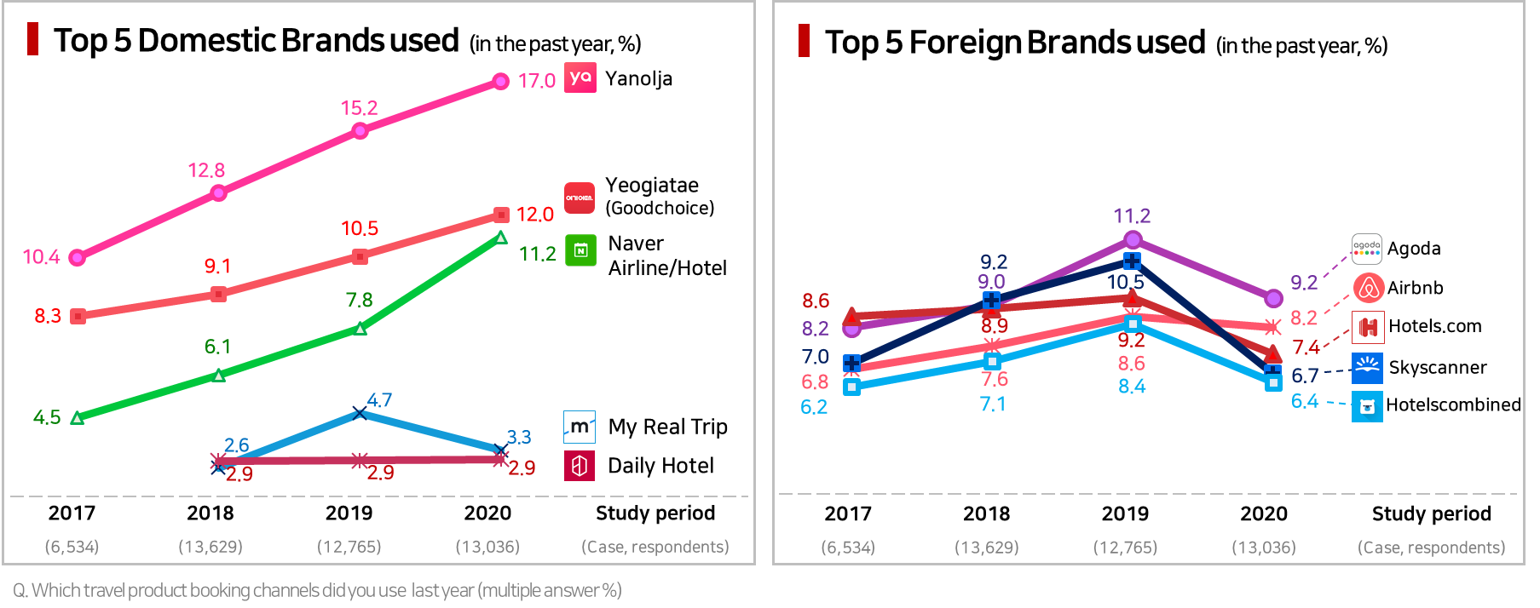
[Figure2] Domestic Brand Use Experience Trend [Figure3] Foreign Brand Use Experience Trend

■ Foreign brands suffer...with Skyscanner falling significantly
The global platforms are suffering greatly, with overseas flight tickets and hotel reservations dropping sharply. Agoda, the second place last year, fell below 10% and stayed in fourth place. Skyscanner, which ranked third, fell 3.8%p from the previous year to 6.7%, pushed down to 7th place. Due to its platform's nature featuring its strengths in booking tickets, Skyscanner was hit directly by the shrink of the travel. Other than those brands, overseas brands such as Airbnb, Hotels.com, HotelsCombined, and Booking.com ranked within the top 9 brands [Figure 3].
■ Challenge the global market while firmly enhancing the domestic dominance
This year, the survey found that some 50.4% of consumers, barely over half of the consumers, responded that they had used travel platforms. Since the first survey in 2017, the trend had been an increase with 42.7% in 2017, 48.6% in 2018 and 53.6% in 2019, but it declined this year for the first time. The results look natural, considering the nuclear bomb-like impact that COVID 19 had on the travel industry. According to ConsumerInsight survey, this year's summer vacation experience rate was also 61.5%, a significant decrease (-17.3%p) from 78.8% last year.
The serious downturn of the global platforms is not limited only to the domestic market. It is a global phenomenon, and their future is extremely uncertain. They will probably be preparing to compete for different products and services in entirely different environments. Such can be an ample opportunity or a threat to local platforms. It is crucial to develop a strategy to secure a strong competitive advantage in Korea while preparing for new threats, by preoccupying the global market that will open again. We need to prepare for a huge market that is hard to meet again
---------------------------------------------------------------------------------------------------------------------------------------------------------
The results are based on 'Travel product satisfaction study” by ConsumerInsight Consumer Trend Research Lab in September 2020. The study surveyed 13,036 people out of ConsuerInsight’s IBP (Invitation Based Panel) with more than 800 thousand panelists as a sample frame. The sampling was done by sex, age, and region proportionally allocated according to national census. The data was collected via email and mobile
---------------------------------------------------------------------------------------------------------------------------------------------------------
Copyright ⓒ Consumer Insight. All rights reserved. No use for commercial purposes allowed.
For-more-Information
Kwon, Younggyo / Director | E. kwonyg@consumerinsight.kr | T. 02)6004-7622

